# Home page:

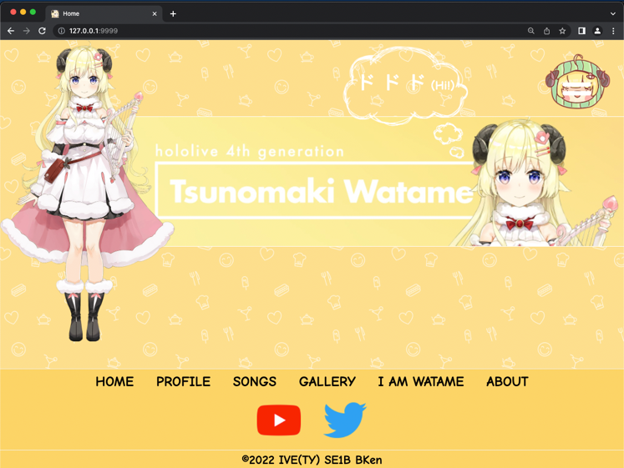

The image and the banner have animation (line-in) when the document is loaded.

The text has animation (fade-in) when the document is loaded.

# Main Menu:

User can click top-right menu button to open this menu. The menu will drop down from the top. The background image will adjust according to the screen size.

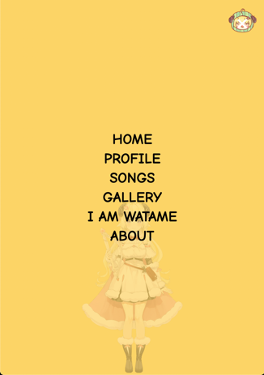 

# Footer:

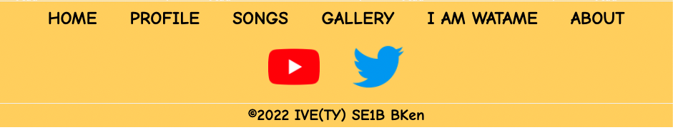

# Profile pages:

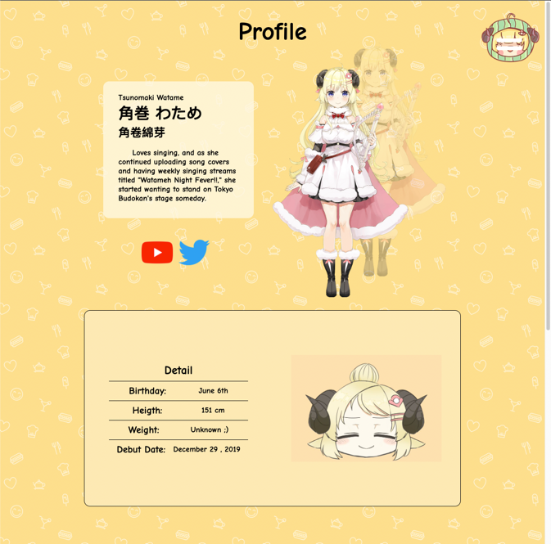

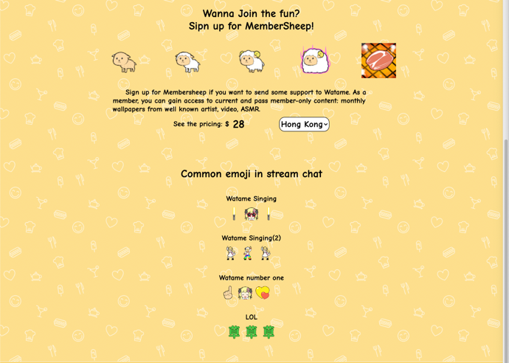

The webpages will ask user sure to go to external link (the social media of Watame) before forward user.

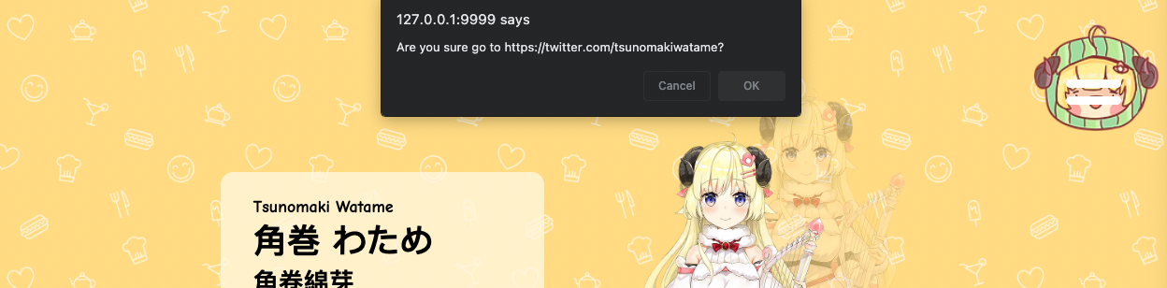

The price of Watame member will changes according the choice of country that user selected.



# Songs pages:

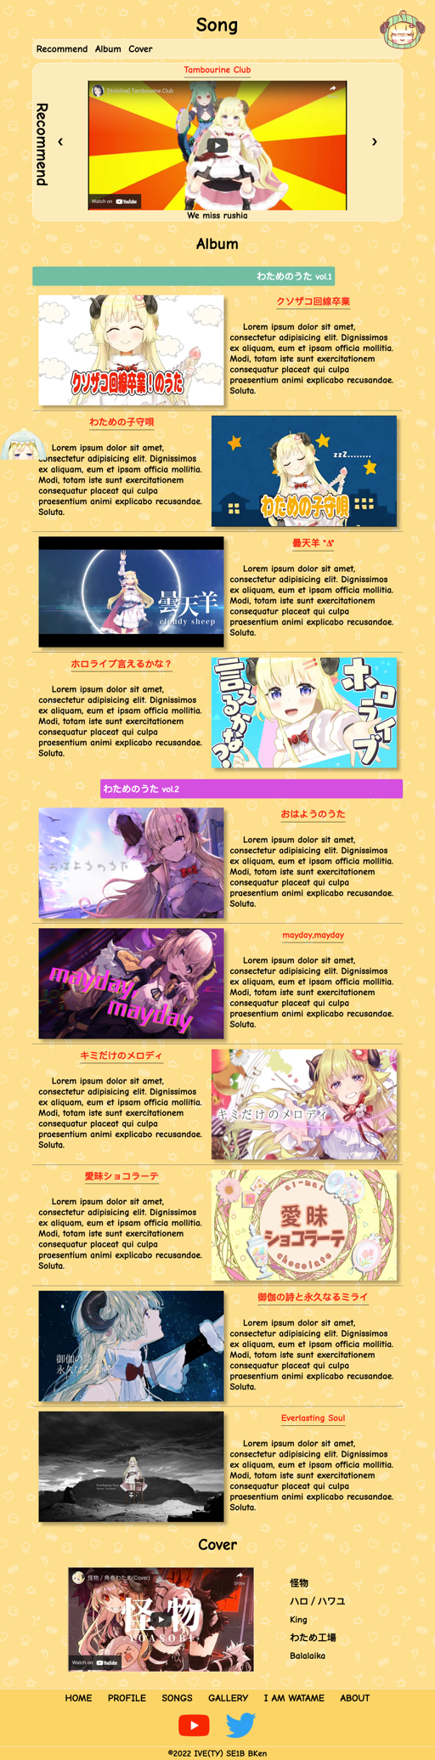 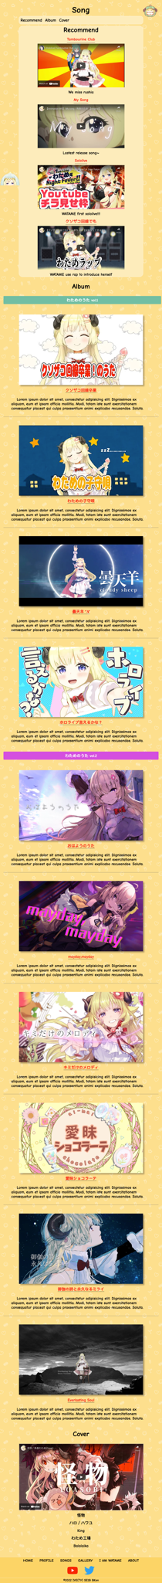

CSS menu:



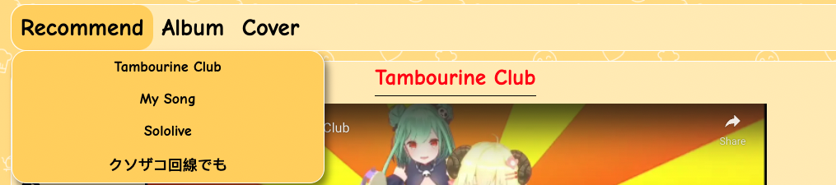

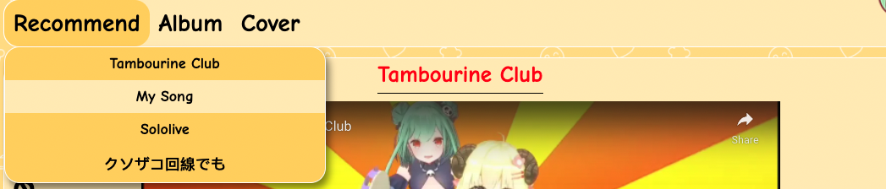

The user need to click on the "Menu" to show the CSS menu when the screen size reach certain width.

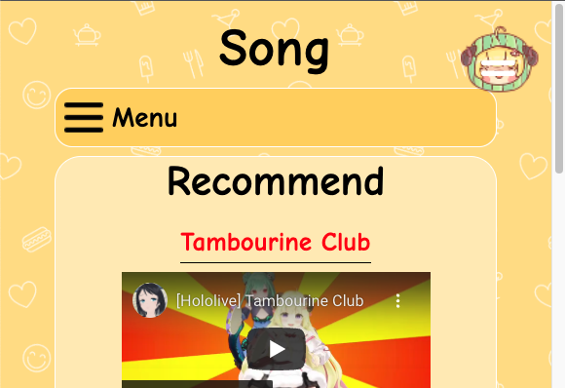 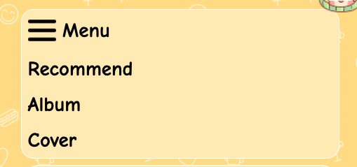

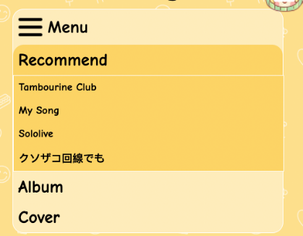

Top button: the user can click the button to back to the top of the page

Origin: 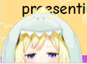 change:

Songs pages is divided into three section.

Recommend section:

The user can press "<" or ">" to changes the video.

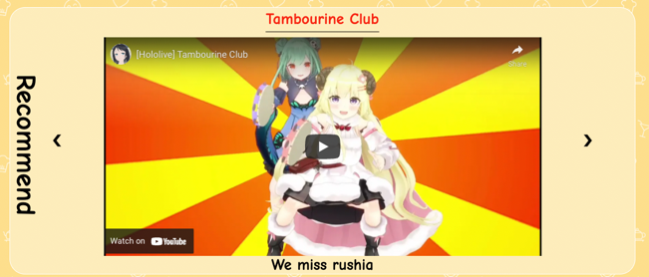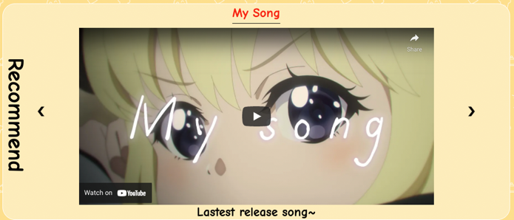

Album section:

One songs have a cover and its description. User can click on the photo to watch according video. The user can click anywhere or the "X" to close the pop up window. The video will automictically stop.

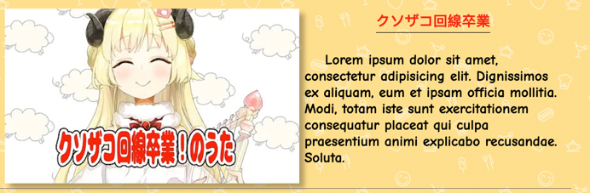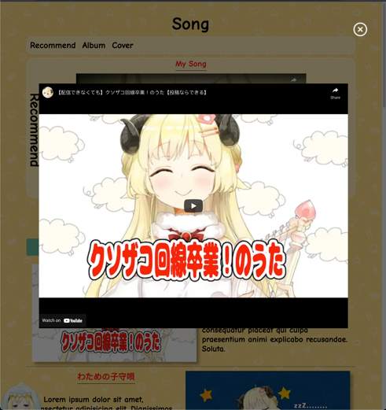

Cover section:

The user can click the songs name at the right side to see the video.

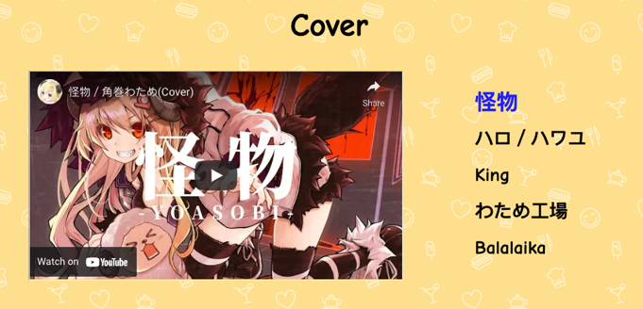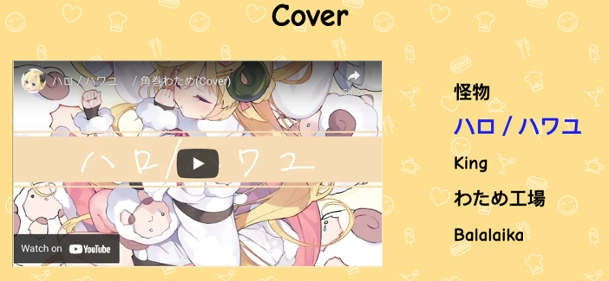

Garllery Pages:

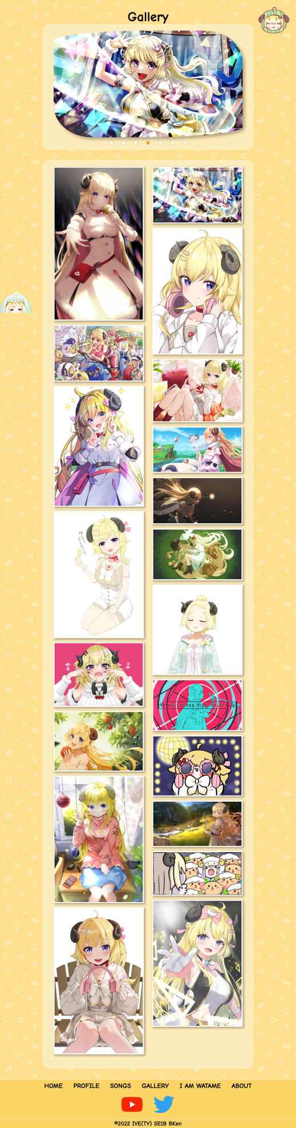 

Carousel :

The photo will changes itself time by time. The user can click on the photo to see more clearly. The user can click anywhere or the "X" to close the pop up window.

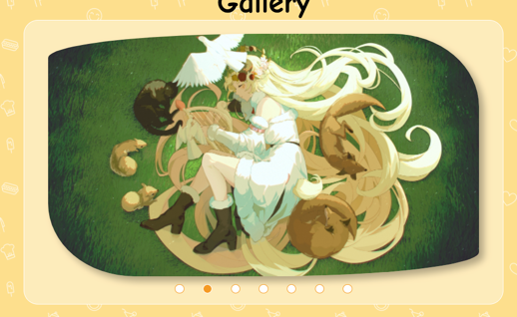 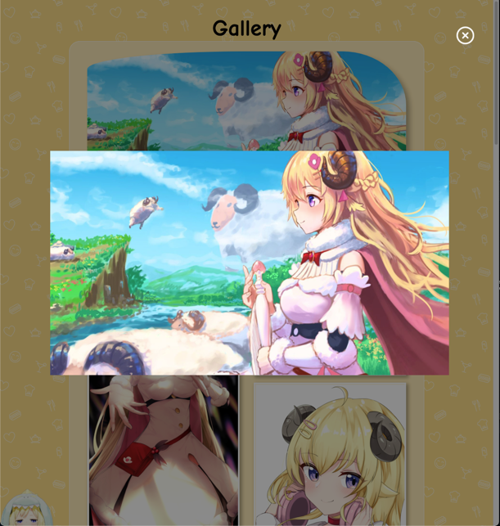

Waterfall:

Different size image are place together as a gallery. The user can click on the photo to see more clearly as above.



I am watame pages:

A audio of watame sound will be played when the user click the button. When the user click the "Back" button, the photo and text will change back to default.

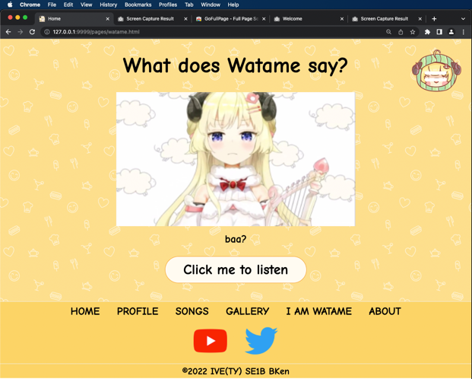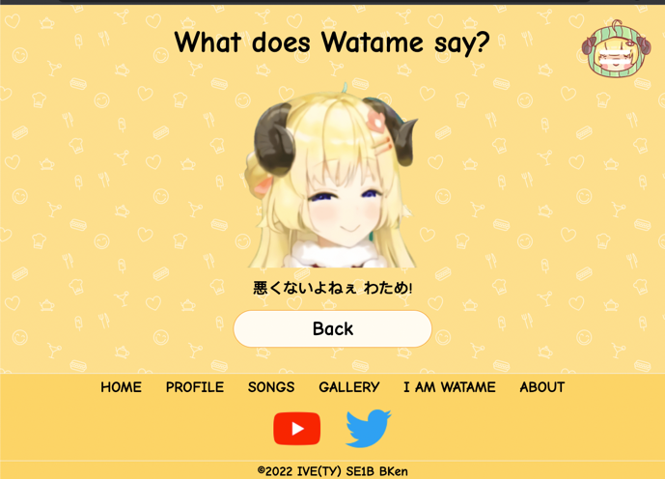

About us pages:

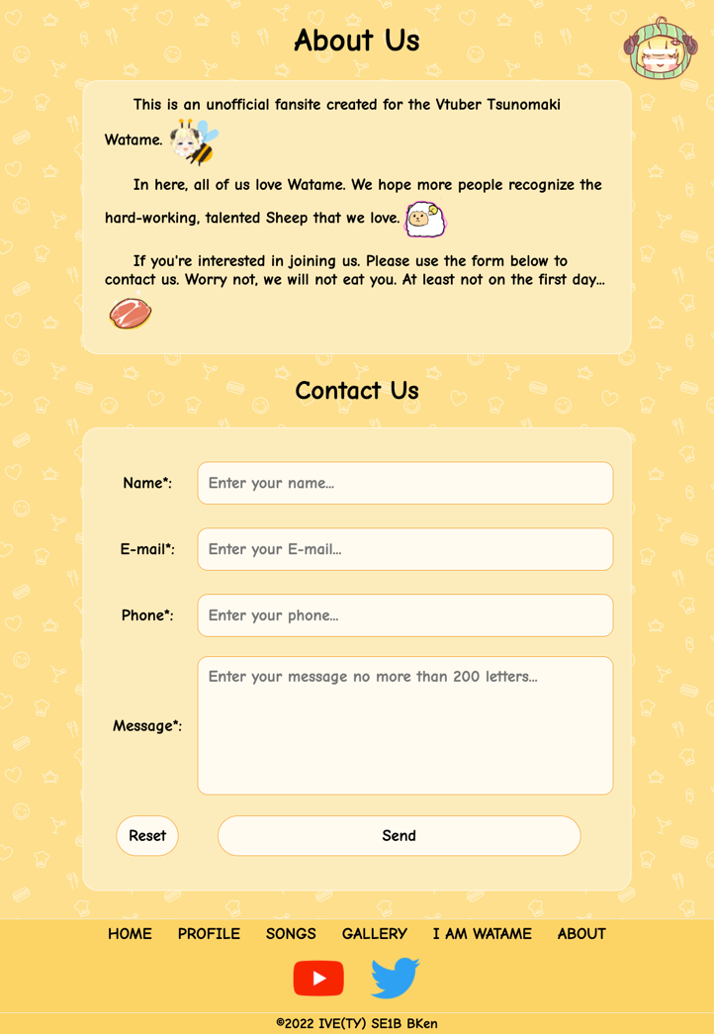

The form is divided into two part for check the input.

The name use html5 attribute to check the pattern.

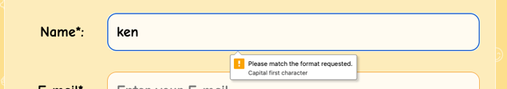 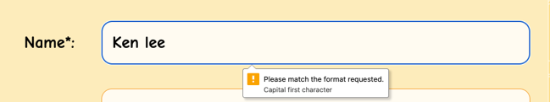

The remaining three part using Javascript to check the pattern. And display a label and a red border when the input does not match the pattern. The border will automactically changes back to normal when the user click on the input boxes. The user can manually close the menu by clicking on "x".

